Information Management

Group Assignment

*Part 1*

**The National Library of Ireland**

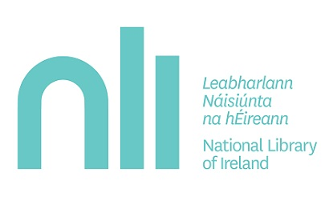

**Group 24**

Sharon Olorunniwo

Jack Donal Collins

Colman Kinane

Tom Wiśniowski

Fintan Gibney

National Library of Ireland

CS2041 - Information Management

Group 24

Group Report Part I

Introduction 2

Our Background Research & How We Collected it 3

Undertaking the Task 4

UML Case Diagram 5

UML Use Case Diagram Scenarios 6

UML Class Diagram 8

UML Class Diagram Description 9

UML Activity Diagram – “*Request Consultation”* 11

UML Activity Diagram – “*Host Consultation”* 12

Ethics Canvas 13

Description of Ethics Canvas 14

Project Contributions 15

Strengths & Weaknesses of UML Design 16

# Introduction

The National Library of Ireland is Ireland’s National Library and is under the remit of the Minister for Arts, Heritage and the Gaeltacht. The National Library provides a multitude of services to not only the Citizens of Ireland but to people from all over the world. The National Archives contain genealogy records dating back prior to the creation of the state.

Our Report aims to model the system used by the national Library and demonstrate the multiple actors that affect the day to day operations of the National Library.

# Our Background Research & How We Collected it

Our Background research focused on what the National Library actually does and more importantly how it does it. We used the National Library Website & Other Government resources extensively to conduct our research.

One of the first questions we asked ourselves was *“so what does the National Library actually do?*” When we think about any library, the first thing in our heads is “renting out books”. The National Library is actually completely different. The primary focus is to gather all material which relates to Ireland and its history and preserve it for future generations. Even if no one visited, the library would continue to collect and store all this information.

There are 5 main things that the National Library does in order to carry out its mission which is determined by Legislation under the authority of the office of the Minister for Arts, Heritage and an Gaeltacht.

1. The primary aims is to collect library materials, relating to Ireland and to provide an accurate record of Ireland's output in manuscript, print and other media for present and future users.
2. Holds the most comprehensive collection of Irish documentary material in the world. They subsequently store the materials and allow the general public to access the materials.
3. Organizes exhibitions, public lectures, and other events involving:  poetry, music, theatre, children's storytelling, creative workshops, and others.
4. Providing a wide range of services for primary, post-primary, third level students, lifelong learners and educators.
5. Provides Genealogy Advisory Service for those beginning family history research.

So how does the Library gather all this material? There are three main ways;

1. **Legal Deposit** - most publishers in are obliged to deposit copies of their publications.
2. **Donation**- Generous individuals may endow a collection to the state or make a donation while they are alive.

1. **Purchase** - Everything which the library sees as valuable source of information, and which they couldn't attain through Legal Deposit is bought in the interest of the state.

Probably the most important thing about the National Library is that it is a closed stack reference library which means that books and other items can’t be taken out and must be ordered for consultation in reading rooms. To actually view material, you need a Reader's Ticket, which you can get only if you're aged 16 years or older and which is valid for a maximum of 3 years. You can then order the material you wish to view, either online or in person, and when it's available you can come in to see it, sometimes you will be designated a certain day and in many occasions, you will be allocated to a particular room to view it in.

# Undertaking the Task

We decided to model how material is requested and accessed by Patrons. The reasons for this was because it was the most intricate system and would allow us to demonstrate to a high level how much goes on behind the scenes of a such a complex organisation. There are three methods of booking a viewing of a material;

1. Online,
2. Telephone,
3. In person.

We will tackle the problem by researching the libraries processes and by mapping the online method of booking a viewing for a material held by the library through the use of UML use case diagrams and UML class diagrams.

# ../Downloads/Use%20Case%20Diagram.pngUML Case Diagram

# UML Use Case Diagram Scenarios

**Requesting a material to view**

**Primary actor(s):**   Patron

                             National Library Login System

  Material Database

Librarian

**Precondition(s):** Valid Reading Ticket

Material is available

Space available in Reading Room

**Normal Scenario:**

1. Patron logs onto the NLI online order system
2. The patron enters their desired material type to view
3. Search material call(ID) number in NLI Catalogue in order to complete the first section of the online order form
4. The patron enters the material Author and Title
5. The patron enters Reading Ticket number to validate their ticket
6. The patrons order is then submitted to the National Library Ireland
7. The material database is then updated
8. The patron arrives at the library desk
9. The librarian validates the patrons Reader Ticket
10. The librarian gives the patron their ordered material
11. The Librarian then assigns the Patron to a Reading Room
12. The Patron completes use of material
13. The Patron returns the material to the librarian
14. The librarian places the material back on the stack
15. The Material Database is then updated

**Special Scenario:**

1. Patron has the option of booking a genealogy consultation
2. The patron requests a consultation at the librarian desk
3. The Librarian checks the availability of a consultation session
4. If there is a slot available the Librarian hosts a consultation session for the Patron

**Error Scenario:**

* 1. **Invalid Reading Ticket**

1. Patron enters the material information in the online application
2. The Patron enters their Reading Ticket number
3. The Patrons Reading Ticket comes back as Invalid
4. The Patron renews their Reading Ticket in person at the National Library
5. **No Reading Ticket**
6. Patron enters the material information in the online application
7. If the Patron does not have a Reading Ticket they fill out the online application after entering the material information
8. **Material is not available/Access Denied**
9. Patron enters the material information in the online order application
10. If the requested material is not available the Patron receives an error message
11. The Patron then has the choice to be put on a waiting list for the requested material
12. **No Reading Spaces available**
13. Patron enters the material information in the online order application
14. If the Reading space is not available the Patron receives an error message
15. The Patron then has the choice to be postpone their viewing to a later date
16. **Library Material Not Returned**
    * 1. Librarian checks list of Materials not returned at the close of business.
      2. Librarian Checks to see if the material has been left at an alternative location, if not he/she will contact the patron to request information about the material.

# ../Downloads/UML%20Class%20Diagram.jpgUML Class Diagram

# UML Class Diagram Description

The National Library model describes the main classes and relationships which could be used during the analysis phase to better understand the National Library’s Management System.

Every library has the following attributes: Address, Establishment Date, Name etc, all of which are in our library class. The library employs more than one librarian and the librarian works for one library, hence the cardinality of one to more than one. There is a composition between the library and the librarian because you cannot have a librarian without a library.

In order to place an order request to view a material in the National Library, a valid Reading Ticket is a requirement, hence we have a composition between the Reading Ticket and Material Request class. The Reader Ticket is only created for one Library and the National Library has multiple Readers Tickets on record for their multiple visitors. Therefore the cardinality between the Reader Ticket and the library is 1 and 0..* For every Patron there is one Reader Ticket. In order to apply for a Reader's Ticket the Patron must supply the following information: Date of Birth, Name, Photographic ID, address. The following attributes are included in the Reader Ticket class, only the Name, Photo, Date of Birth are the pieces of information that is public in the Reader's Ticket class the other attributes have restricted visibility. The Reader's Ticket has a issue and expiry date. The cardinality between the Reading Ticket and Material Request classes is between 0...3, this is because a Patron can only order up to 3 items to view at a time.

Without a material request there would be no reason to book a reading room hence the composition between the material request class and the Reading_Room Booking class.

When a material order request is processed and approved the material database is updated. In the National Library the materials are separated into seven categories: Maps, Newspaper, Book, Journal, Newspaper, Manuscript and Musical Score. For this reason we decided to use subclasses instead of aggregation relationships. This was because we felt subclasses were more appropriate and made sense in regards to material organization in the database and library. The material category subclasses inherit from the material class. Regardless of type, every single item in the National Library available for viewing in the National Library has the following attributes: ItemID, ItemName, ItemDescription, ItemPermissionLevel, ItemSource. The database class must be able to notify the librarian and patron if a particular material is unavailable for a viewing. Once the order has been assigned and confirmed the librarian allocates a reading room to the patron. The cardinality between Room_Booking class and Reading Room location class is one and one because every Reading_Room booking only books one location.

The library also offers consultation on genealogy records for patrons who request it. The Consultation_Booking class requests availability of a library consultant to host the viewing for the patron. The Library_Consultant confirms the consultation availability. The cardinality between the Consultation_Booking class and Library_Consultant class is one and one. There is a composition relationship between the Consultation_Booking class and Consultation class, without a consultation booking there is no consultation session.

# UML Activity Diagram – “*Request Consultation”*

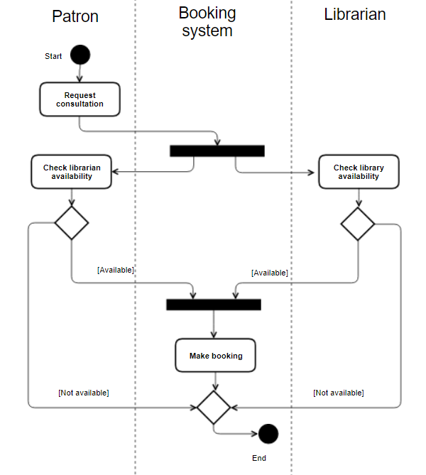

Description

The request consultation is a meeting between a patron of the library and a librarian about genealogy. The process starts with the patron requesting the consultation. The request triggers the system to check the availability of the librarian and for space in the library. These checks return either a negative or positive result. If both checks come back positively then the booking is made. If either is negative the booking cannot be made.

# UML Activity Diagram – “*Host Consultation”*

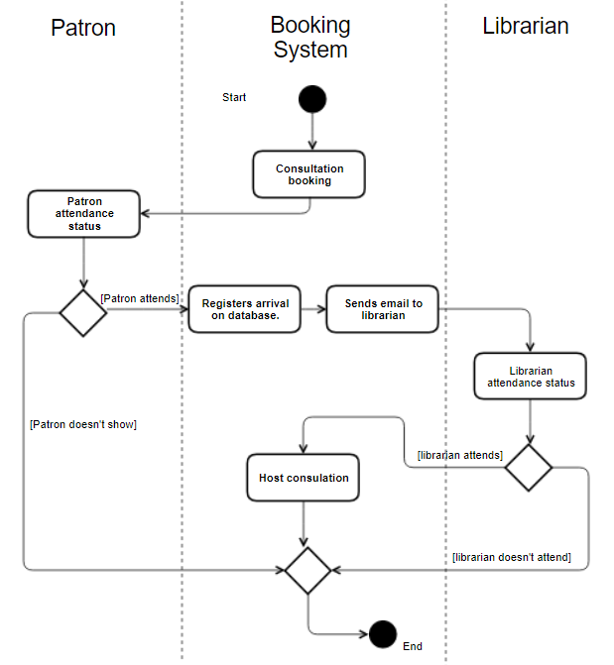

Description

Assuming that the consultation has been created in the system and scheduled correctly. When the patron arrives, they can go to the desk and make the librarian on duty aware of their appointment, the booking system will email the librarian scheduled to meet with the patron that they have arrived, It can also allow the librarian to cancel the meeting if an unscheduled conflict has arisen.

# ../../../../../Desktop/Screen%20Shot%202017-11-12%20at%2016.21.05Ethics Canvas

# Description of Ethics Canvas

In General Terms Libraries tend to be seen as quite ethical organisations who merely persevere data in so far as they can, so as to be a reference for current and future generations. With respect to the National Library, decisions about what kind of data (Census, Genealogy records & Legal Deposit Laws) are principally decided by the state and the Library has no legal influence over it.

One of the biggest challenges facing the National Library and particularly the state, is the storage of digital content. This type of content is often edited without the original data being preserved. For example, if the state updated a website it might not make a previous version of the site available online.

**Additional Explanations of Ideas**

**Individuals & Groups Affected**

The Library has many stakeholders, ranging from a University Academic to Book & Material publishers. Publishers have to manage their legal responsibility to the Library while Academics are the most common users of the Library facility.

**Behaviour**

Historically the Library has been able to store all major documents of historical importance. However, with the advent of the internet, over the next few years the library will have to look at becoming a permanent digital store of Information. Storing copies of webpages which are of importance to the state. Legal Deposits may also be extended to E-Books.

**Relations**

The relationship the National Library has with the people of Ireland is incredibly important, It allows people to find out more about their past, learn more about Irish history or what the opinions of the people of Ireland were at certain points in our history.

**Worldviews**

The Library has a legal and moral obligation to remain apolitical and to record and maintain a record of all publications regardless of their nature. It is incredibly important that the library retains the highest level of ethics when it comes to maintaining and recording documents which could be seen as distasteful by the majority of the population. For example, In Germanys case it is incredibly important they maintain Nazi propaganda documents even though such documents don’t represent the beliefs of the people they still form an integral part of that nation’s history.

**Problematic Use of Resources**

It is often the case in science and in history that facts that were once thought to be true are no longer so. It would be problematic and impossible for a Library to keep a record of all cases where material in its archive has been disproven as it is the library’s responsibility to simply maintain a record and not ensure accuracy.

**Product or Service Failure**

If proper records of materials being intrusted to the national Library are not kept it is possible that materials could be lost, stolen or simply forgotten about.

**Uncategorised Ideas**

As the National Library is a public institution they must comply with the Ethics in Public Office Act. This act ensures they behave in a proper manor and prevents political decisions being made within the national Library,

# Project Contributions

**Introduction & Background Research** – Jack Donal Collins & Tom Wiśniowski

**UML Case Diagram** – Whole Group Contributed

**UML Case Diagram** Scenario Descriptions – Sharon Olorunniwo

**UML Class Diagram** - Whole Group Contributed

**UML Class Diagram Description** - Sharon Olorunniwo

**UML Activity Diagrams & Descriptions** – Colman Kinane

**Ethics Canvas & Ethics Canvas Description** – Jack Donal Collins

**Strengths & Weaknesses of Design** – Colman Kinane, Jack Donal Collins & Sharon Olorunniwo

# Strengths & Weaknesses of UML Design

**UML Case Diagram**

**Strengths**

Our use case diagram clearly shows the process of using the online booking system of the National library. It is clearly laid out and is intuitive and gives a clear view of the interactions of the various actors amongst each other and also with the system as a whole.

We believed our UML Case Diagram should be more or less the blueprint for the UML Class Diagram. This influenced the choices made in the design process. It was vital the it accurately reflected the overall function of the system.

**Weaknesses**

The weakness of this UML case diagram is that it doesn’t show the range of bookings and services provided by the library. It is a very basic version of the library’s management system. For example, it does not address the fact that the library patron has the option to view a multitude of different materials of different types.

The reason we decided to design a simplified Use Case Diagram, was to allow us to demonstrate the key fundamental processes of the library’s management system without going into all the intricacies of the entire booking system process.

**UML Class Diagram**

**Strengths**

The class diagram gives a much more detailed description of the operations within the library.

Our UML Class Diagram makes good use of inheritance which is evident in our overall design. The National Library has different types of materials available for viewing, so we initially created separate classes for each material type. We quickly realised that these classes possessed similar attributes so we took this as an opportunity to make good use of inheritance and created a main Material class with the different types as subclasses. By doing this we were able to display more clearly the entire operation whilst maintaining the complexity of the system.

**Weaknesses**

Perhaps the biggest weakness of our class diagram is its readability. We found it difficult to find a good balance between displaying as much information as we could and also making it easy to interpret. I could definitely see people with no prior knowledge of UML having great difficulty interpreting the diagram. But the detail in the diagram is admirable and well laid out given the exorbitant amount of information within said diagram.

**UML Activity Diagram**

**Strengths**

The strengths of the UML activity diagram is similar to the Use case diagram is it's easy to read nature. They are well labelled and the process is fairly intuitive. It gives a clear and whole view of the process of ‘booking a consultation’. Makes use of the joins and forks operations which make the flow of the activity clearer to a reader. Our diagram makes use of swim lanes which give a clearer view of which objects are responsible for which internal activity.

**Weaknesses**

A weakness of our UML activity diagram is that the activities chosen and the selection of activities there was to choose from were quite narrow. We, as a collective, felt that the activities were already narrowed down significantly in our UML use case diagram. There was not proverbial meat on the bones left on the activities to make a nice extensive UML activity diagram

**UML Case Diagram**

**Strengths**

In Summary, Our Design shows the operations of the National Library in a detailed fashion. We believe our design is accurate in the way it displays how each actor interacts with the system.  Gave a nice step by step view of the array of activities and classes that we looked at. We believe our UML Class Diagram is detailed and could easily be transferred into XML for the second part of the project. When we started out we set out to complete the entire project with the end goal in sight so as to ensure our XML implementation could be easy to understand and more importantly easier to implement.

**Weaknesses**

A weakness of our overall design is that it looks at a rather narrow scope of the library. Perhaps a criticism of our design is that it doesn’t deal with the processes of cataloguing and such other library activities. The reason for this was that there was very little information on the cataloguing process that was readily available. There is a limited amount of information given by the NL.